Applying ICT for Innovation in Higher Education Management through the Use of Data Driven Decision Making and Proper Governance.

Change in higher education is the only constant. As the world gets smaller with innovations in technology, what becomes clear is the importance of the application layer. In our cases it is not the reassembly of the data packets, but rather the innovative and fluent use of technology throughout the system.

Queens College is an example of an organization that has recognized the need to align information and communication technologies with the strategic plan and mission of the college. This was not very difficult to do as ICT is embedded in the fabric of everything we do today. If you want to increase on-line learning, then you need video conferencing and lecture capture. If you want to be able to do it well you need and instructional designer to help your faculty build the curriculum for the course. It all continuously goes back to the old adage “People, Process, and Technology”.

Three years ago Queens College embarked on a project to build a strategic plan towards the Queens College of 2015. It realized that technology is embedded in our lives. “The rules of the new economy are based on knowledge and networks and are very different from those of the manufacturing-based economy.” With Queen College vision for 2015 to be “known as a top 5 best value institution, Global in reach, character, and focus it benefits and contributes to its location in one of the nation’s most diverse counties.”
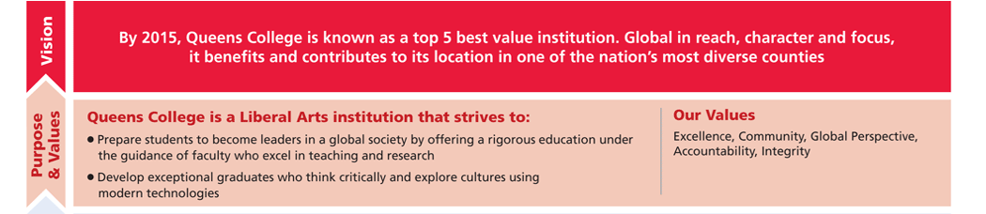

Then we must focus on developing and applying technology to enable our students, faculty, and staff to compete in the ever-changing Global economy. We can only do that by developing cohesive strategic priorities that feed this vision. Knowing the importance of technology to the future of the College, the President commissioned a committee of individuals representing Academics and Administrative areas to focus the efforts of the Office of Converging Technologies (ICT Department) and other departments on the development and execution of these priorities in an 18 month cycle and to monitor their development across that timeframe with the Strategic Plan as the framework of these priorities. The Committee met three times:
- To develop the concept, ground rules, and charge the sub-committees of the Greater Vision Strategy Execution (VSE) Committee with their focus on developing their priorities. (June 30, 2010)
  - The Charge was built on:
    - Honest discussion without judgment or recourse.
    - Benefit the Institution as a whole.
    - Use the Strategic Plan as a guide
    - Limit the focus on the application of Technology
    - Commitment to support the implementation.

- The second meeting was held on August 16th after the sub-committees met in their own groups. Three major ideas were presented:
  - Virtual Communities with Virtual Access to Information and Knowledge
  - Improved Learning Environments
  - Data driven decision-making
It became quickly apparent that college needed to focus on these criteria and not all could be accomplished. It was in the third meeting that as the Greater Committee and with all sub-committees present that the overarching committee was able to decide on an overall ICT vision that “Queens College provides a robust technological environment to a community with functional technological literacy at a global scale.”
The idea was to stay true to the core and look at building systems and models that can become the foundation for future strategic priorities thereby meeting the goals of the overall Queens College Strategic Plan.
The Committees developed the following three Strategic Priorities:
- Knowledge anywhere anytime globally
- Next generation global learning environment
- Continuous improvement and oversight via data-driven decision making
Each of the priorities is teamed with specific deliverables, as prescribed in the Vision, Strategy, and Execution plan (attached). These all have a roadmap for delivery within 18 to 24 months.
Simultaneously in order to implement the Continuous Improvement Process a Institutional Intelligence Advisory group consisting of faculty, leadership, and administrators is created to review the progress of projects and develop new strategic priorities for future implementations.
Although the process above is focused is from an ICT perspective, this can be adopted throughout the University and across really any industry vertical.
Innovation in higher education is not technology. Technology is ubiquitous and constantly changing. Innovation comes from governance and alignment with the strategic plan. Ensuring that all of the business and academic units are in sync with the vision and values of the organization guarantees that the limited resources funding and human are used efficiently and effectively to the benefit of the college community.
The benefits of this process are synchronicity of the college’s departments with the plans, but more importantly buy-in to the outcomes. These outcomes can be:
- Increase Enrollment and Retention
- Improve Data Driven Decision-making in order to streamline activities and increase revenue sources.
- Enhance the pedagogical experience through the enlightened use of technology.
- Create a culture of accountability through continuous improvement

In today’s economy it is not about natural resources or products. It is about knowledge capital. Knowledge capital increases entrepreneurship, sustainability and the viability of our institutions. The college is in business of building tomorrow’s citizens and it behooves us to ensure that our students are empowered to become the Global citizens that contribute to the good of humankind.

Craig Canine, Dream Reaper: The story of an Old-Fashioned Inventor in the High-Tech, High Stakes World of Modern Agriculture (New York: Knopf, 1995)

